**ASSIGNMENT 3**

**NAME : Monisha R**

**ROLL NO. : 412419104066**

### PROJECT: Emerging Methods for Early Detection of Forest Fires

1. Create a Bucket in IBM object storage.

Bucket name : div.assignment-3

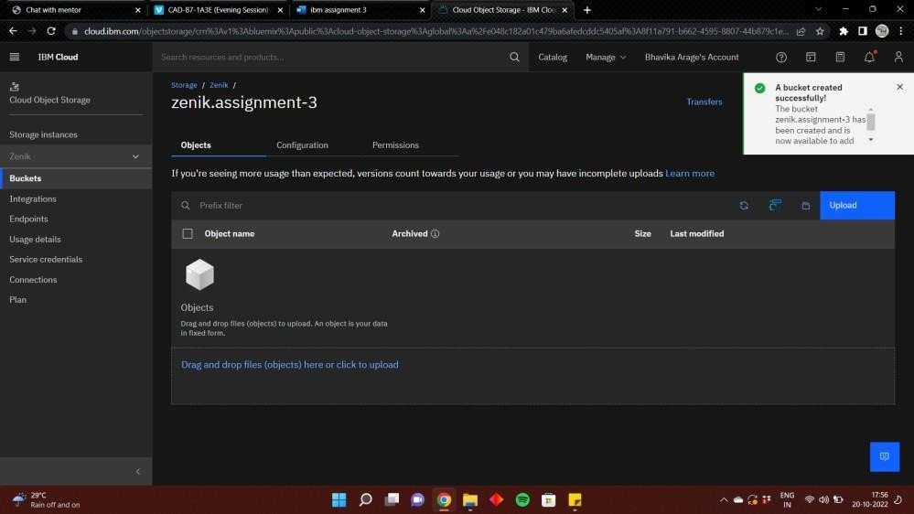

1. Upload 5 images to ibm object storage and make it public. write html code to displaying all the 5 images.

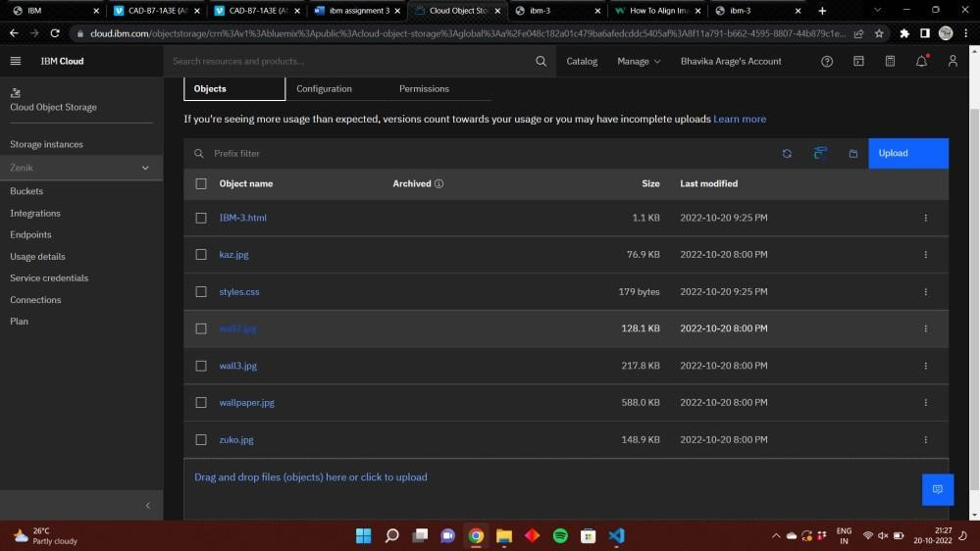

1. Upload a css page to the object storage and use the same page in your HTML code.

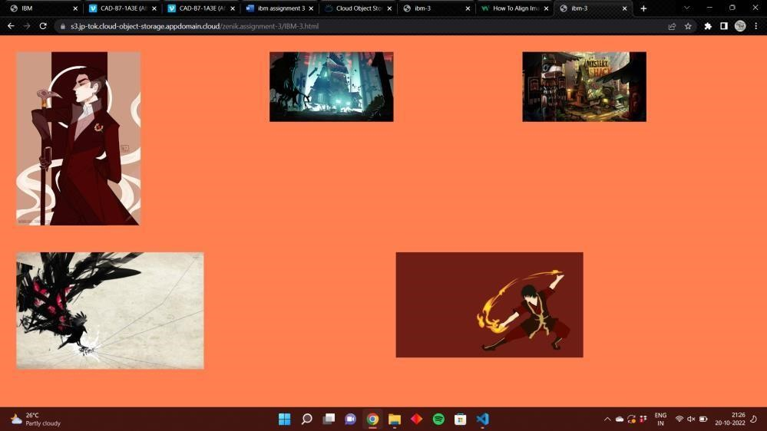

1. Design a chatbot using IBM Watson assistant for hospital. Ex: User comes with query to know the branches for that hospital in your city. Submit the web URL of that chat bot as a assignment.

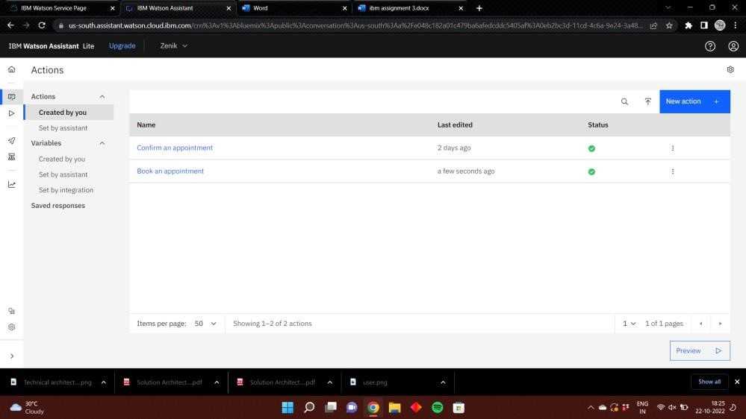

[https://api.us-south.assistant.watson.cloud.ibm.com/instances/0eb2bc3d-11cd- 4c6a-9e24-3a482bf2ff12](https://api.us-south.assistant.watson.cloud.ibm.com/instances/0eb2bc3d-11cd-4c6a-9e24-3a482bf2ff12)

1. Create Watson assistant service with 10 steps and use 3 conditions in it. Load that script in HTML page.

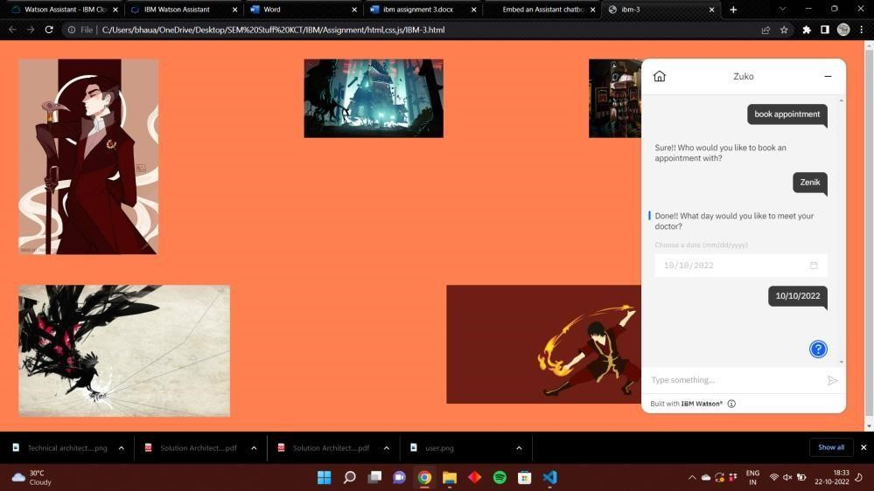

<!DOCTYPE html>

<html lang="en">

<head>

<link rel="stylesheet" href="styles.css">

<meta charset="UTF-8">

<meta http-equiv="X-UA-Compatible" content="IE=edge">

<meta name="viewport" content="width=device-width, initial-scale=1.0">

<title>ibm-3</title>

</head>

<body>

<div class="row">

<div class="column">

<img src="https://s3.jp-tok.cloud-object-

storage.appdomain.cloud/zenik.assignment-3/kaz.jpg">

</div>

<div class="column">

<img src="https://s3.jp-tok.cloud-object-

storage.appdomain.cloud/zenik.assignment-3/wall2.jpg">

</div>

<div class="column">

<img src="https://s3.jp-tok.cloud-object-

storage.appdomain.cloud/zenik.assignment-3/wall3.jpg">

</div>

</div>

<div class="row">

<div class="column">

<img src="https://s3.jp-tok.cloud-object-

storage.appdomain.cloud/zenik.assignment-3/wallpaper.jpg">

</div>

<div class="column">

<img src="https://s3.jp-tok.cloud-object-

storage.appdomain.cloud/zenik.assignment-3/zuko.jpg">

</div>

</div>

<script> window.watsonAssistantChatOptions = {

integrationID: "bff04632-77ec-42fc-b7b0-4c7babf6a78a", // The ID of

this integration.

region: "us-south", // The region your integration is hosted in.

serviceInstanceID: "0eb2bc3d-11cd-4c6a-9e24-3a482bf2ff12", // The ID of

your service instance.

onLoad: function(instance) { instance.render(); }

}; setTimeout(function(){ const t=document.createElement('script');

t.src="https://web-

chat.global.assistant.watson.appdomain.cloud/versions/" +

(window.watsonAssistantChatOptions.clientVersion || 'latest') + "/WatsonAssistantChatEntry.js";

document.head.appendChild(t);

});

</script>

</body>

</html>